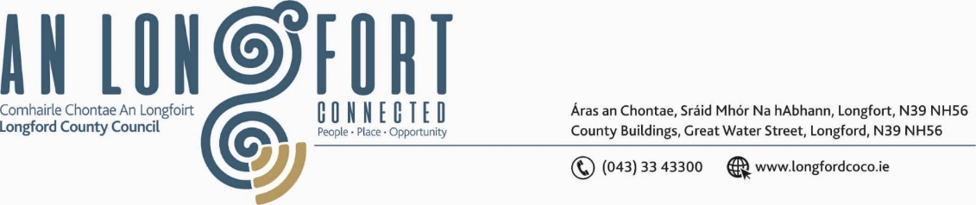

***BALLYMAHON MUNICIPAL DISTRICT***

***Please note meeting will be held via Microsoft Teams and in Edgeworthstown Library.***

**21 March 2022.**

**To: Each Member of Ballymahon Municipal District.**

**Dear Member,**

You are requested to attend a Meeting of Ballymahon Municipal District to be held

**in Edgeworthstown Library and via Microsoft Teams** on **Friday 25 March 2022 at 3.15pm** to transact business, as set out on the Agenda hereunder.

**Yours sincerely**,

Ann Marie Mc Keon

_______________

**Ann Marie Mc Keon,**

**Meetings Administrator.**

**AGENDA**

Prayer before meeting.

**1.** Confirmation of Minutes of Ballymahon Municipal District Meeting held on

the 27 January 2022 – copy enclosed.

**2.** Matters arising from Minutes.

**3.** Declaration of Interest by Members.

**4.** Management Report - enclosed.

**5.** Consideration of Schedule of Ballymahon Municipal District Works – enclosed.

**6.** Proposed Projects/Expression of interest.

**7. Notices of Motions, submitted by Councillors, as listed hereunder –**

**Councillor Paul Ross**

(i) “I call on Longford County Council to upgrade the road markings on Main Street, Edgeworthstown at the Park House junction as the current markings are gone and the junction is causing confusion to drivers”.

(ii) “I call on Longford County Council to take out a long-term lease on the Harbour in

Barley Harbour in Newtowncashel to preserve and enhance the county's only harbour in one of Ireland's tidiest villages”.

**Councillor Gerard Farrell**

(i) “I call on the roads department to look at updating signage and improve safety measures at Lanesboro national school and Fermoyle national school”.

(ii) “I propose that Lanesboro tidy towns be supported in securing project funding for a bronze sculpture at the N63 junction”.

**Councillor Mark Casey**

(i) That this council engages with the landowner of Barley Harbour with the view of the council purchasing the harbour and surrounding lands

(ii) That a full-time staff member is made available for Lanesborough Town team with the purpose of supporting the Town team with funding applications and to work with all stake holders that are involved with the just transition.

(iii) That funding be made available for the repair and replacement of the lights under the bridge in Lanesboro, currently only one of the 7 arches is lit.

**Councillor Colm Murray**

(i) “I call on Longford County Council to erect a boundary wall or fence at the new housing estate on Carton Road, Kenagh”.

(ii) “I call on Longford County Council to carry out verge improvement works along the L-5196 from Bawn Mountain to Ardagh.”

**Councillor Pat O’Toole**

(i) “I call on Longford County Council to extend the public lighting on the N.55 Edgeworthstown Road Ballymahon from Leo Casey GAA grounds to the Ballybrannigan Road the L 5225”.

(ii) Given the level of new services that have been installed in Ballymahon over the past number of years e.g. water mains, gas mains sewerage lines etc, I call on Longford County Council to draw up a guide map indicating where the pipes are located on the Main Street and on adjoining roads which would be very beneficial not just for the council itself but to any utility company who may have excavate the street at any time in the future.

(iii) “I call on Ballymahon Municipal District Council to host a Civic Recognition for the Ballymahon Vocational School Under 19 Basketball Team that won the All-Ireland C Basketball Championship on March 8th in the National Basketball Arena in Tallaght”.